## Introduction

The Enabled Controller Mini is a switch and analog joystick interface. It allows for an analog joystick to be used as either a gamepad, or an alternative computer mouse. Makers Making Change has a range of analog joysticks that are compatible with the Enabled Controller Mini. Featured in this project is the Oak Compact Joystick – A, or Oak – A for short. It is a midsized joystick that has a range of toppers with varying sizes that can be securely attached and removed with a 3D printed collet.

## Features

Enabled Controller Mini

Interact Switch

Oak Compact Joystick - A

## Usage

As this project features two devices to be used together, this guide is broken into two sections: the usage of the Oak Compact Joystick - A and its accessories, and the usage of the Enabled Controller Mini.

### Oak Compact Joystick and Accessories

The Oak Compact Joystick – A has a range of toppers and mounting solutions.

#### Changing the Topper

The current range of Oak Joystick Toppers.

Ball Concave Convex Goalpost Stick

Installing and replacing the topper requires three 3D prints: the topper itself, the nut, and the collet. The image below shows the ball topper, nut, and collet, from left to right.

Collet

Nut

Ball Topper

Step 1

Place the nut over the black joystick shaft. The threads should be towards the top of the joystick, while the octagonal section should be towards the bottom.

##### Step 2

Place the collet on the black joystick shaft. The two ends of the collet have different thicknesses to them. The side of the collet that is thinner should go over the joystick shaft first, so that the thicker side is pointing up and away from the joystick. Note: if the collet does not sit at least ¾ of the way into the nut in this orientation, then the collet is likely upside down.

##### Step 3

Slide the nut up the joystick shaft just under the collet and line up the threads on the bottom of the topper with the nut. Thread the nut into the topper and tighten by hand.

To remove the topper, simply unscrew the nut and remove the topper. Note that you may require pliers or a wrench to grip the octagonal bottom of the nut if the topper is screwed on too tight.

#### Mounting the Joystick

The Oak Compact Joystick can be mounted using various methods, depending on your preference and how you can best access it.

**Note**: A different joystick is shown is the following mounting examples, but the same principles and methods will apply to this joystick.

##### Table Top Mounting – Non-Slip Pads

|  |  |
| --- | --- |
| If using the joystick on a tabletop, and height of the joystick is not a concern, nonslip pads can be added in each of the four corners on the bottom, as shown. |  |

##### Table Top Mounting – Hook and Loop Fastener

|  |  |
| --- | --- |
| If using the joystick on a tabletop or other surface with hook and loop fasteners, such as Velcro, stick the hook side (rough side) to the joystick and the loop side (soft side) to the surface to mount to. | Bottom of the joystick with hook and loop fastener attached to the bottom. The hook side is shown stuck to the joystick. |

##### Camera Mount

To mount the joystick on a camera mount, the optional Joystick Camera Mount Adapter can be used by simply screwing it to the bottom with two M3 screws.

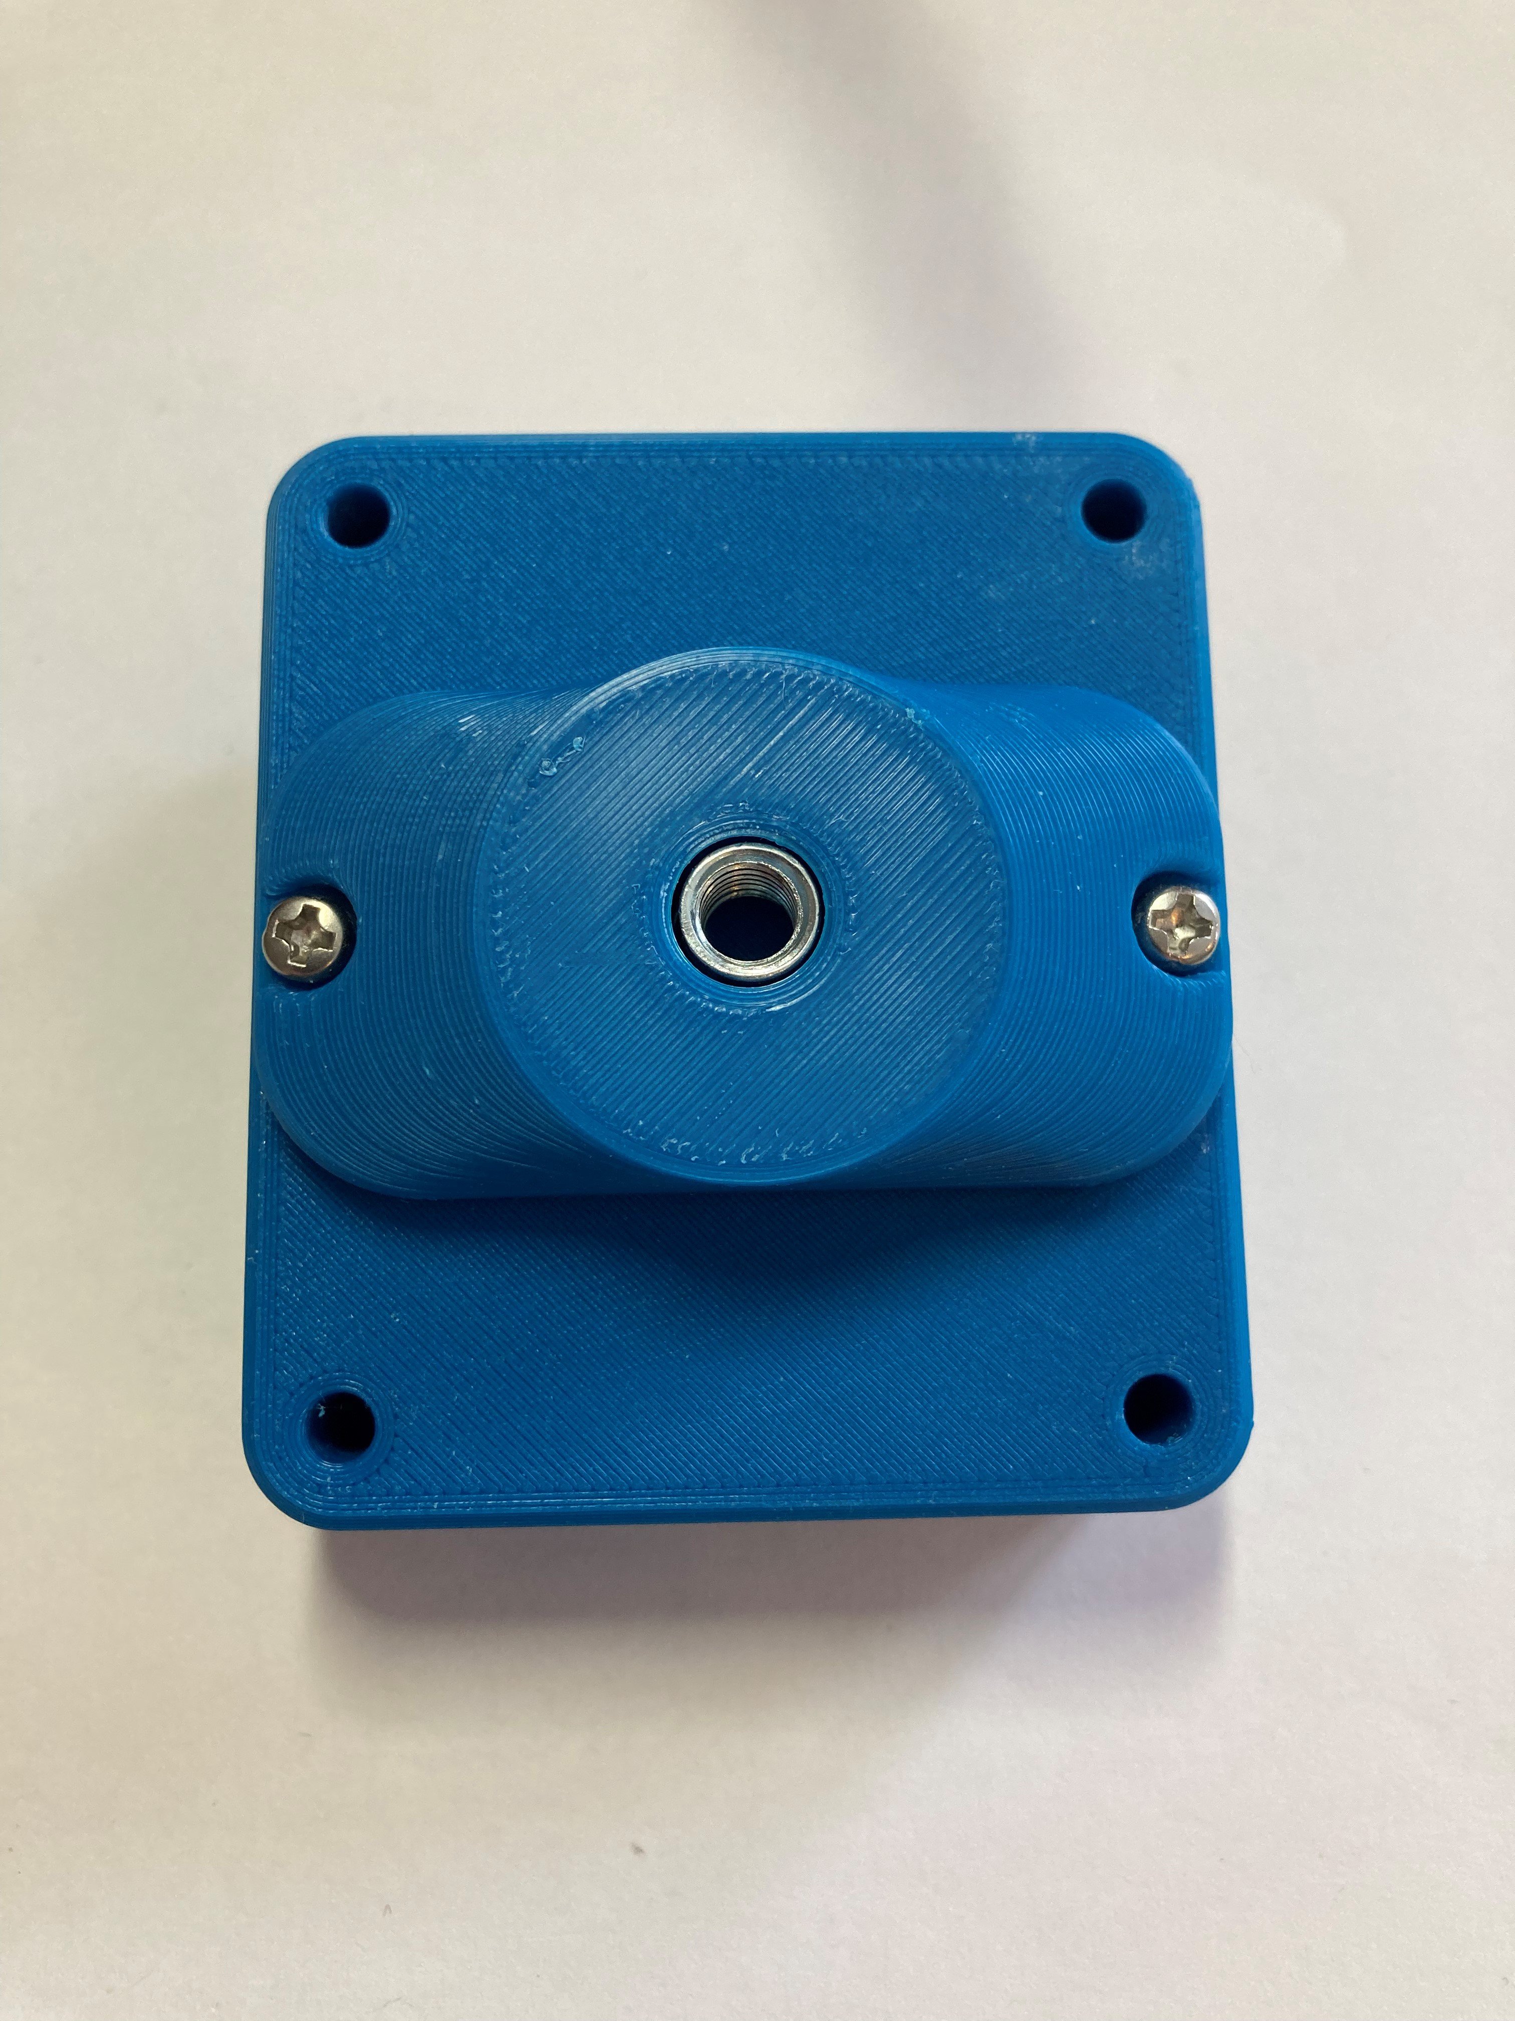

### Enabled Controller Mini

When paired with the Enabled Controller Mini and a few assistive switches, any analog joystick (TRRS cable) can be used as either a gaming joystick, or as a computer mouse.

To switch between the two versions, the code must be reflashed to the microcontroller using Arduino IDE on a computer. Before flashing the code, **Line 36, Mouse_Mode_Enabled**, must have its value edited to either “true” or “false”. True will enable Mouse Mode, while false will default to Gamepad Mode.



#### Mapping

When using the Mouse code, the analog joystick becomes the means of moving the mouse across the screen, while the assistive switches become your other mouse functions. When using the Gamepad code, the analog joystick and assistive switches function as a gamepad. When in gamepad mode, the buttons can be mapped to specific inputs in whatever game or compatible application it is being used in. Default mappings are given in the table below.

|  |  |  |  |  |
| --- | --- | --- | --- | --- |
| **Switch** | **Mouse** | **Joystick** | | |
| **PC** | **XAC (left)** | **XAC (right)** |
| Joystick | Cursor Movement | Joystick Movement | Left Thumbstick | Right Thumbstick |
| A | Left click | Button 1 | X1 | View |
| B | Middle click (scroll) | Button 2 | X2 | Menu |
| C | Right click | Button 3 | Left stick (left press) | Right stick (right press) |
| D | Left click | Button 4 | Left bumper | Right bumper |

Instructions for some methods of changing the joystick mappings when in gamepad mode are given below.

##### Steam

When you connect the Enabled Controller Mini to your PC for use with Steam, you will have to configure it as a controller before you can use it in game.

1. Open Steam and go to the settings menu.

1. Select ‘Controller” in the Settings sidebar menu.

1. Select QT P as the controller and click on Test Device Inputs.

1. Select “Setup Device Inputs” and follow the prompts given. A and B must be mapped, but any other functions can be mapped to your preference or skipped altogether. Note that you only have 4 buttons available with this setup.

##### Xbox Adaptive Controller (XAC)

To connect to the XAC, simply plug in the Enabled Controller Mini into either the left or right USB joystick port and plug your respective joystick and switches into your Enabled Controller Mini.

Instructions for mapping the controls of your Enabled Controller Mini and Joystick for the XAC can be found at <https://support.xbox.com/en-CA/help/account-profile/accessibility/customize-adaptive-controller-in-xbox-accessories-app>

##### Joystick Gremlin & VJoy

Open source software such as [Vjoy](https://github.com/shauleiz/vJoy) and [Joystick Gremlin](http://whitemagic.github.io/JoystickGremlin/) can be used to combine other inputs with the joystick.

## Compatibility

The Oak Compact Joystick – A plugs into the Analog input on the Enabled Controller Mini and the remaining four switch inputs, A, B, C, and D will accept any standard [assistive switches](https://makersmakingchange.com/resource/device-selection-guide-switches/).

The Enabled Controller Mini has both a mouse mode and a gamepad mode that have different compatibilities. The following table breaks out what systems this device is compatible with in each mode.

|  |  |  |
| --- | --- | --- |
| System | Mouse Mode | Gamepad Mode |
| PC | Yes | Direct or via XAC |
| Mac | (Yes, but untested) | (Yes, but untested) |
| Android Mobile | (Yes, but untested | Yes, and also through XAC |
| Apple Mobile | (Yes, but untested) | Yes, and also through XAC |
| Xbox | (Yes, but untested) | Through XAC |
| PS4 | (Yes, but untested) | Through XAC with an adapter |
| PS5 | (Yes, but untested) | Through XAC with an adapter |
| Nintendo Switch | (Yes, but untested) | Through XAC with an adapter |
| Linux | (Yes, but untested) | (Yes, but untested) |

A categorised list of relevant adapters can be found at [the MMC Assistive Technology in Gaming Resource](https://makersmakingchange.com/resource/assistive-technology-in-gaming/).

## Specifications

|  |  |
| --- | --- |
| Joystick Range of Motion | ± 25° |
| Joystick Range of Motion | ± 30 mm (default, changes with topper) |
| Joystick Activation Force | 525 grams |
| Total Height | 65 mm |
| Enclosure Height | 34.4 mm |
| Enclosure Width | 80 mm |
| Enclosure Length | 80 mm |
| Weight | 152 grams |

## Cleaning

Wipe the outside of the device with a lukewarm, damp cloth. Do not use hot water on this device or the plastic housing may warp. Do not submerge the device.